|  |  |
| --- | --- |
| **Mã số sinh viên** |  |
| **Họ và tên** |  |
| **Lớp** |  |

**BÀI TẬP CHƯƠNG 1**

* 1. Define in your own words: (a) intelligence, (b) artificial intelligence, (c) agent, (d) rationality, (e) logical reasoning.

Your answer: …..

**1.1)  
Define in your own words:  
(A) Intelligence  
(B) Artificial intelligence  
(C) Agent  
(D) Rationality  
(E) Logical reasoning**

**1.1)  
A) Intelligence is the the ability to solve problems, no matter how miniscule or extraordinary they are. Not only should we be able to solve these problems, but also find improvements to our solutions and continue to expand our knowledge. Being intelligent is one thing, but being able to expand our Intelligence is far more valuable.**

**B) Artificial Intelligence is a piece of machinery, programming, code, etc that was built by humans with the specific task to solve a problem or many problems. But as I’ve stated before, solving problems is one thing, expanding that problem solving knowledge is another. Artificial Intelligence should keep records of its attempts to solve a problem so that it can learn from it’s progress and its mistakes.**

**C) Agents are things that perform actions. They are given instructions and are expected to follow them; but there’s more to it than just following those actions. Agents must also be able to operate on their own, change their actions depending on their surroundings, maintain themselves over an elongated period of time, and develop their own goals to pursue.**

**D) Rationality is doing what is expected of you or what is acceptable to do. When a problem arises there are specific ways that one would solve it; these are filed under Rationality. For example: Your car runs out of gas while driving on the highway and you pull over to solve the problem. A rational action would be to call AAA or a tow service. An irrational action would be to try an siphon gas from a nearby parked police cruiser.**

**E) Logical Reasoning is the ability to perceive a problem logically and know which solution is best to solve it.**

* 1. Read Turing’s original paper on AI (Turing, 1950). In the paper, he discusses several objections to his proposed enterprise and his test for intelligence. Which objections still carry weight? Are his refutations valid? Can you think of new objections arising from developments since he wrote the paper? In the paper, he predicts that, by the year 2000, a computer will have a 30% chance of passing a five-minute Turing Test with an unskilled interrogator. What chance do you think a computer would have today? In another 50 years?

Your answer: …..

* 1. Are reflex actions (such as flinching from a hot stove) rational? Are they intelligent?

Your answer: …..

**Đúng vậy, các hành động phản xạ là có lý trí - chúng ta không cần phải có trí thông minh để thực hiện chúng. Khi bạn có bàn tay của bạn trên một bếp nóng, bạn chỉ cần lấy nó ra mà không cần suy nghĩ. Những phản ứng đó đến từ tủy sống của bạn chứ không phải từ não của bạn. Quá trình thông minh và tư duy được thực hiện ở não, trong khi tất cả các hành động phản xạ được thực hiện bởi tủy sống. Nó hợp lý ở chỗ nó đang tối ưu hóa lợi nhuận của mình. Nó thông minh ở chỗ có hai lựa chọn.**

* 1. Suppose we extend Evans’s ANALOGY program so that it can score 200 on a standard IQ test. Would we then have a program more intelligent than a human? Explain.

Your answer: …..

* 1. The neural structure of the sea slug Aplysia has been widely studied (first by Nobel Laureate Eric Kandel) because it has only about 20,000 neurons, most of them large and easily manipulated. Assuming that the cycle time for an Aplysia neuron is roughly the same as for a human neuron, how does the computational power, in terms of memory updates per second, compare with the high-end computer described in Figure 1.3?

Your answer: …..

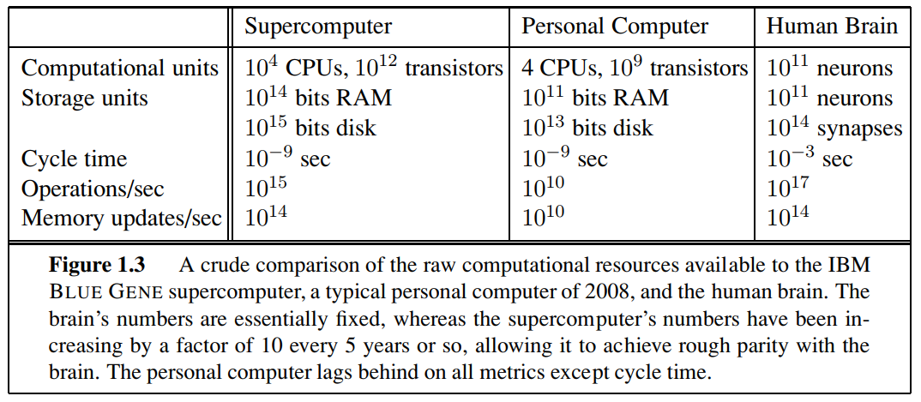

* 1. How could introspection—reporting on one’s inner thoughts—be inaccurate? Could I be wrong about what I’m thinking? Discuss.

Your answer: …..

* 1. To what extent are the following computer systems instances of artificial intelligence:
* Supermarket bar code scanners.
* Web search engines.
* Voice-activated telephone menus.
* Internet routing algorithms that respond dynamically to the state of the network.

Your answer: …..

* 1. Many of the computational models of cognitive activities that have been proposed involve quite complex mathematical operations, such as convolving an image with a Gaussian or finding a minimum of the entropy function. Most humans (and certainly all animals) never learn this kind of mathematics at all, almost no one learns it before college, and almost no one can compute the convolution of a function with a Gaussian in their head. What sense does it make to say that the “vision system” is doing this kind of mathematics, whereas the actual person has no idea how to do it?

Your answer: …..

* 1. Why would evolution tend to result in systems that act rationally? What goals are such systems designed to achieve?

Your answer: …..

* 1. Is AI a science, or is it engineering? Or neither or both? Explain.

Your answer: …..

* 1. “Surely computers cannot be intelligent—they can do only what their programmers tell them.” Is the latter statement true, and does it imply the former?

Your answer: …..

* 1. “Surely animals cannot be intelligent—they can do only what their genes tell them.” Is the latter statement true, and does it imply the former?

Your answer: …..

* 1. “Surely animals, humans, and computers cannot be intelligent—they can do only what their constituent atoms are told to do by the laws of physics.” Is the latter statement true, and does it imply the former?

Your answer: …..

* 1. Examine the AI literature to discover whether the following tasks can currently be solved by computers:

1. Playing a decent game of table tennis (Ping-Pong).
2. Driving in the center of Cairo, Egypt.
3. Driving in Victorville, California.
4. Buying a week’s worth of groceries at the market.
5. Buying a week’s worth of groceries on the Web.
6. Playing a decent game of bridge at a competitive level.
7. Discovering and proving new mathematical theorems.
8. Writing an intentionally funny story.
9. Giving competent legal advice in a specialized area of law.
10. Translating spoken English into spoken Swedish in real time.
11. Performing a complex surgical operation.

For the currently infeasible tasks, try to find out what the difficulties are and predict when, if ever, they will be overcome.

Your answer: …..

* 1. Various subfields of AI have held contests by defining a standard task and inviting researchers to do their best. Examples include the DARPA Grand Challenge for robotic cars, The International Planning Competition, the Robocup robotic soccer league, the TREC information retrieval event, and contests in machine translation, speech recognition. Investigate five of these contests, and describe the progress made over the years. To what degree have the contests advanced toe state of the art in AI? Do what degree do they hurt the field by drawing energy away from new ideas?

Your answer: …..